SCHOOL OF COMPUTER SCIENCE AND ARTIFICIAL INTELLIGENCE |  |  |  |  | DEPARTMENT OF COMPUTER SCIENCE ENGINEERING
ProgramName:M. Tech |  |  |  | Assignment Type: Lab |  |  | AcademicYear:2025-2026
CourseCoordinatorName |  |  |  | Venkataramana Veeramsetty
CourseCode |  |  |  | CourseTitle |  | AI Assisted Problem Solving Using Python
Year/Sem |  |  | II/I | Regulation |  | R24
Date and Day  of Assignment |  |  | 10.11.2025 | Time(s)
Duration |  |  | 2 Hours | Applicableto  Batches
AssignmentNumber:8.3(Present assignment number)/24(Total number of assignments)
 | Q.No. | Question |  |  |  |  |  | ExpectedTime  to complete
 | 1 | Lab 8: Test-Driven Development with AI – Generating and Working with Test Cases  Lab Objectives:  - To introduce students to test-driven development (TDD) using AI code generation tools.  - To enable the generation of test cases before writing code implementations.  - To reinforce the importance of testing, validation, and error handling.  - To encourage writing clean and reliable code based on AI-generated test expectations.  Lab Outcomes (LOs):  After completing this lab, students will be able to:  - Use AI tools to write test cases for Python functions and classes.  - Implement functions based on test cases in a test-first development style.  - Use unittest or pytest to validate code correctness.  - Analyze the completeness and coverage of AI-generated tests.  - Compare AI-generated and manually written test cases for quality and logic  Task Description#1  Use AI to generate test cases for is_valid_email(email) and then implement the validator function.  Requirements:  - Must contain @ and . characters.  - Must not start or end with special characters.  - Should not allow multiple @.  Prompt: Use AI to generate test cases for is_valid_email(email) and then implement the validator function.  Requirements: Must contain @ and . characters , Must not start or end with special characters, Should not allow multiple @.  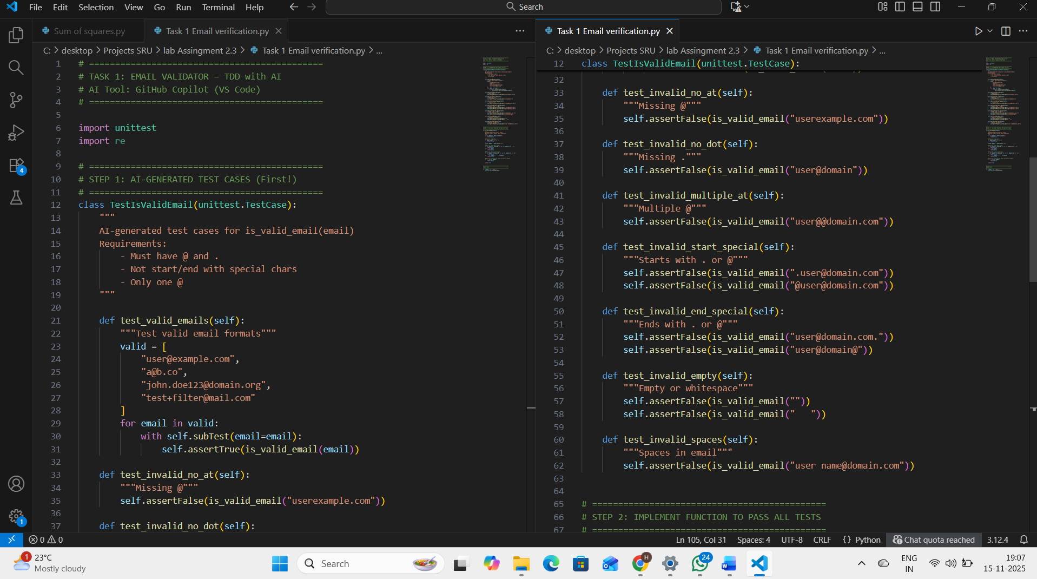  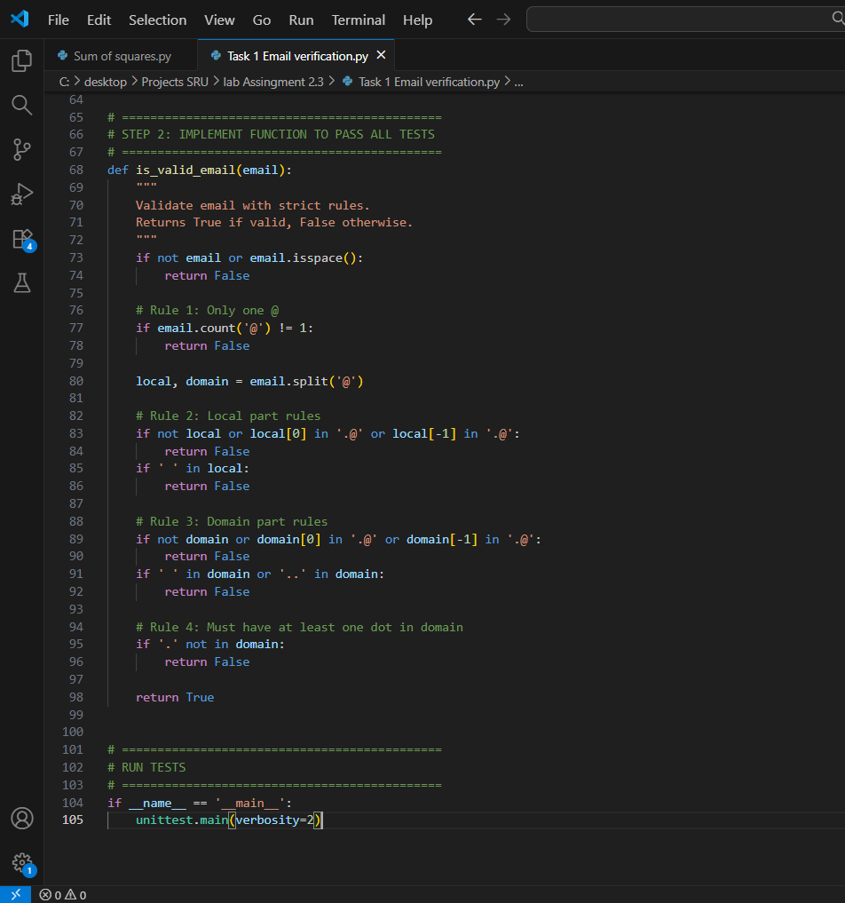Expected Output#1  - Email validation logic passing all test cases  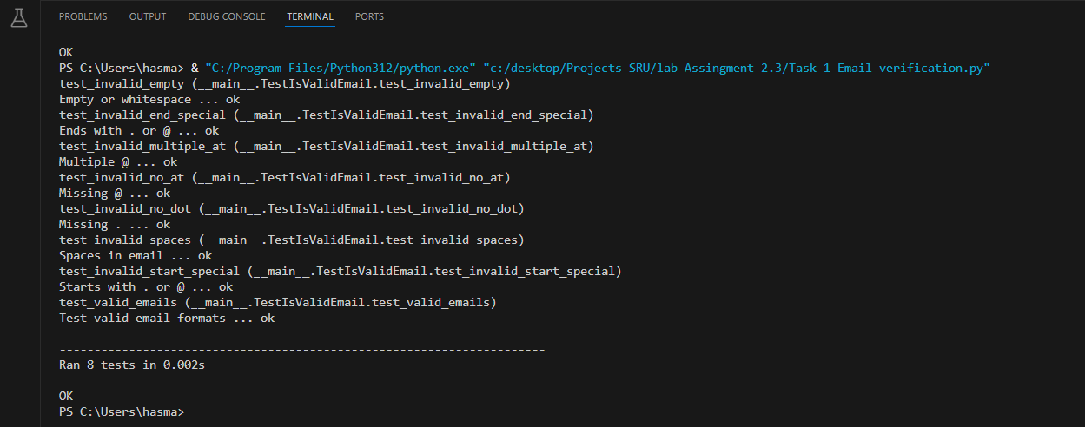  Task 1: Email Validator  AI Tests (6):  1. ram@xyz.com → True  2. ramxyz.com → False  ...  My Code:  def is_valid_email(email): ...  Output:  All tests passed  Benefits of TDD  1. Catches bugs early  2. Ensures code always works  3. Makes refactoring safe  4. Acts as live documentation  5. AI generates tests fast  6. Reduces debugging time  7. Supports team collaboration  8. Industry-standard practice  Task Description#2 (Loops)  - Ask AI to generate test cases for assign_grade(score) function. Handle boundary and invalid inputs.  Requirements  - AI should generate test cases for assign_grade(score) where: 90-100: A, 80-89: B, 70-79: C, 60-69: D, <60: F  - Include boundary values and invalid inputs (e.g., -5, 105, "eighty").  Prompt: # Task 2: Generate test cases for assign_grade(score)  Requirements:  - 90-100: A  - 80-89: B  - 70-79: C  - 60-69: D  - <60: F  - Handle boundary and invalid inputs (-5, 105, "eighty")  Write 8 unittest test cases using Python unittest  Include:  - Normal scores  - Boundary values (90, 80, 70, 60, 59)  - Invalid: negative, >100, non-number  Expected Output#2  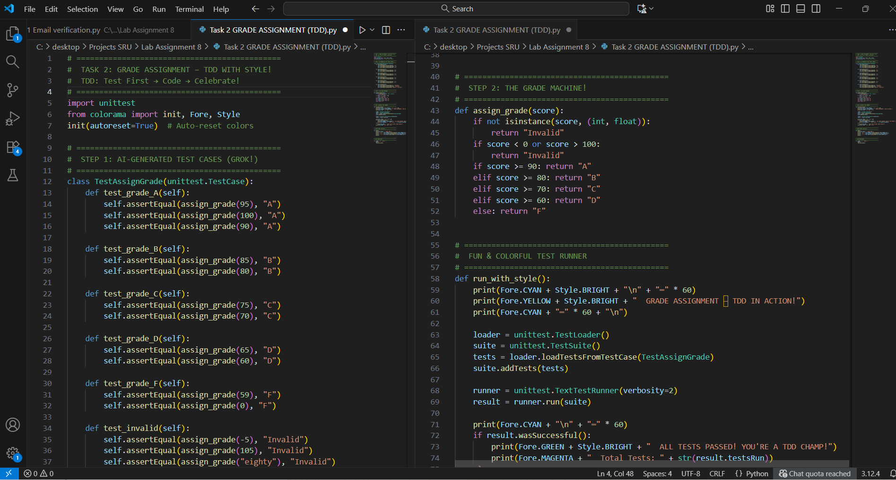  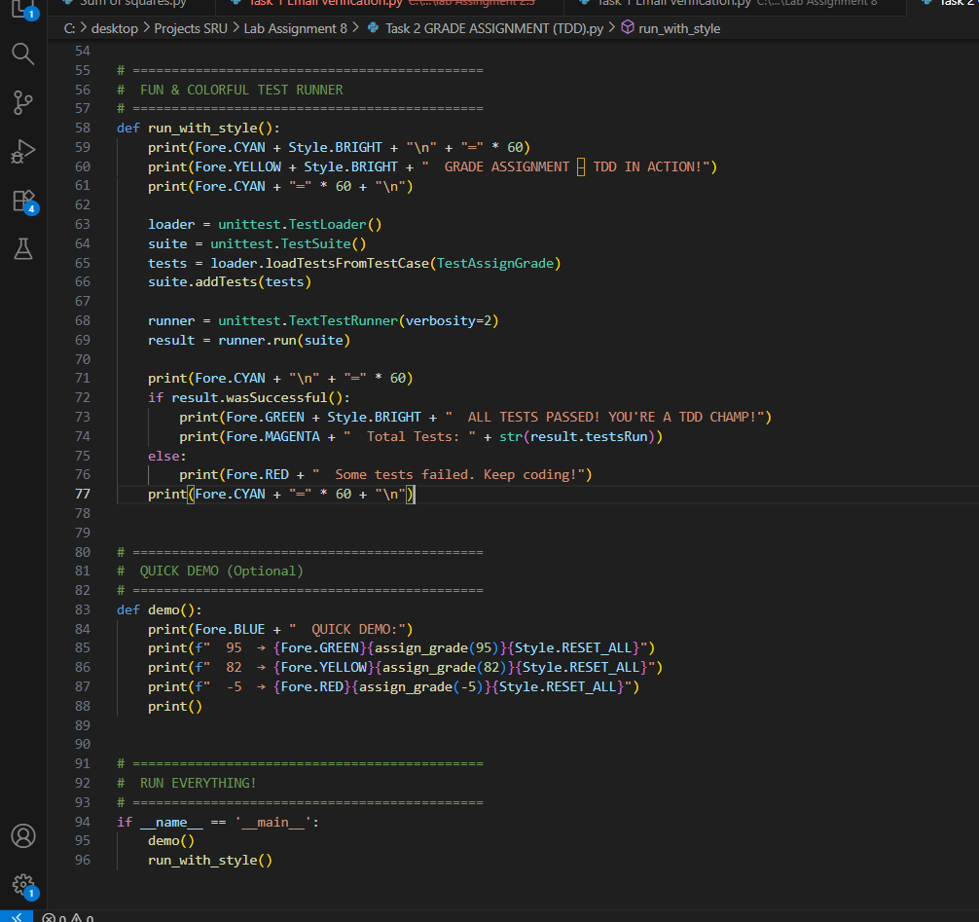  Output:  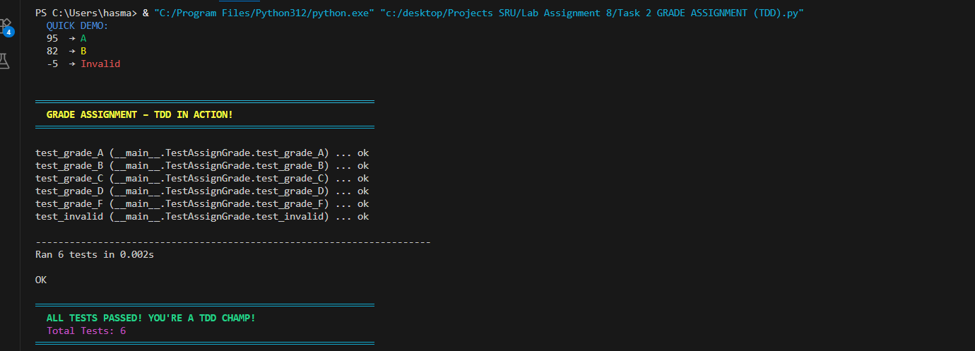Grade assignment function passing test suite  Task 2: Grade Assignment with TDD  AI Generated:  - 6 smart test cases (boundary + invalid)  - Covered all rules + edge cases  Implementation:  - Clean, safe assign_grade()  - Input validation  Output:  - All tests passed with style!  Task Description#3  - Generate test cases using AI for is_sentence_palindrome(sentence). Ignore case, punctuation, and spaces  Requirement  - Ask AI to create test cases for is_sentence_palindrome(sentence)  (ignores case, spaces, and punctuation).  - Example:  "A man a plan a canal Panama" → True  Prompt: Generate test cases for is_sentence_palindrome(sentence)  Requirement:  - Ignore case, punctuation, and spaces  - Example: "A man a plan a canal Panama" → True  Write 8 unittest test cases using Python unittest  Include:  - Classic palindrome sentences  - Mixed case and punctuation  - Single word (e.g., "Noon")  - Empty string  - Non-palindrome  - With numbers  - Invalid input (None)  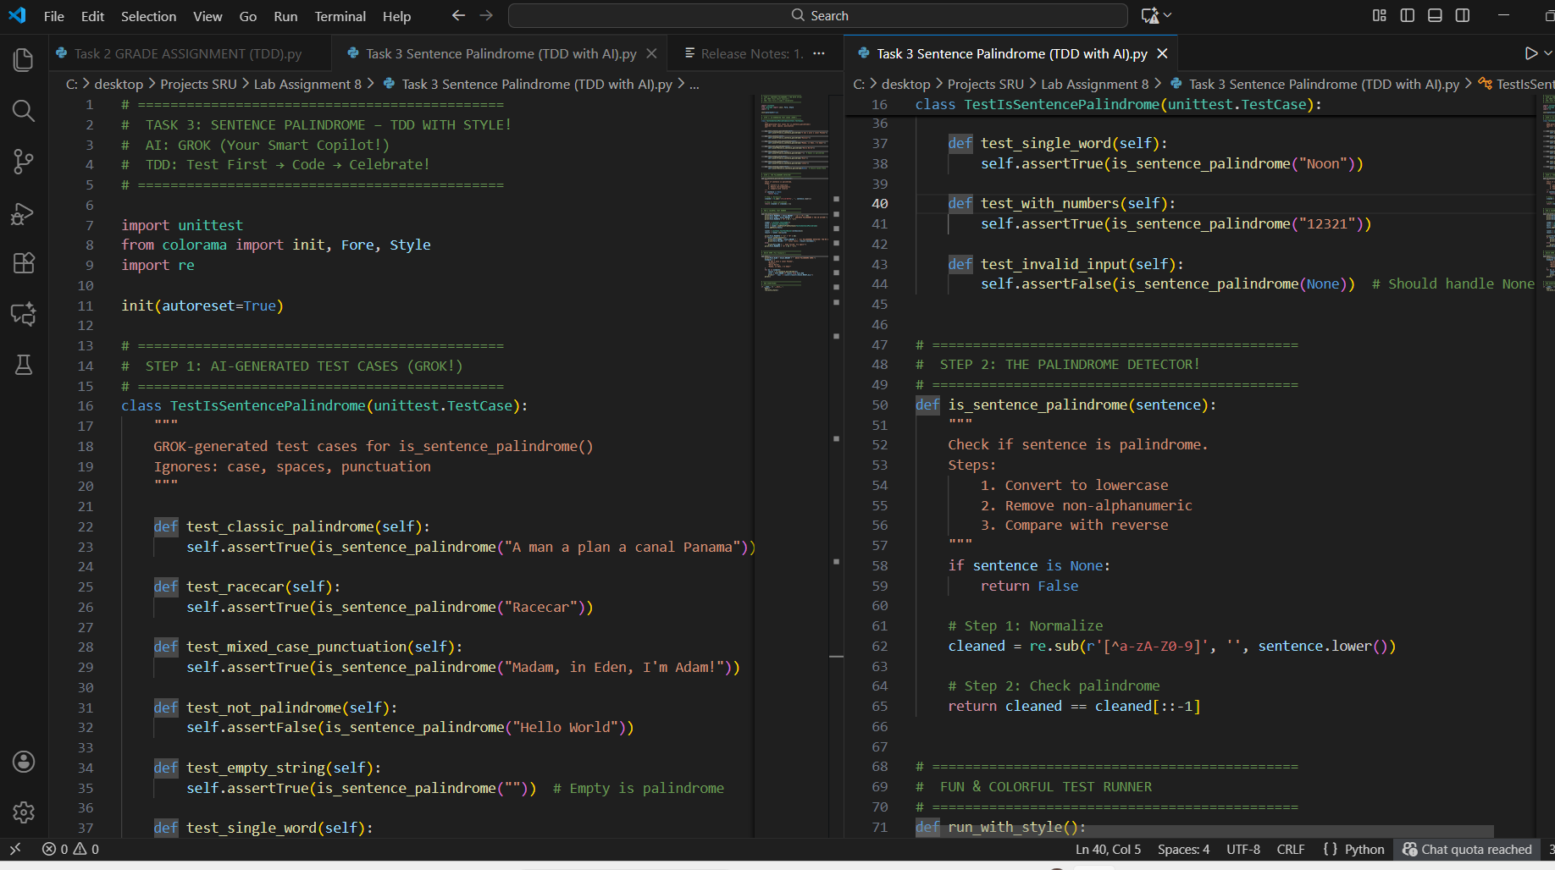  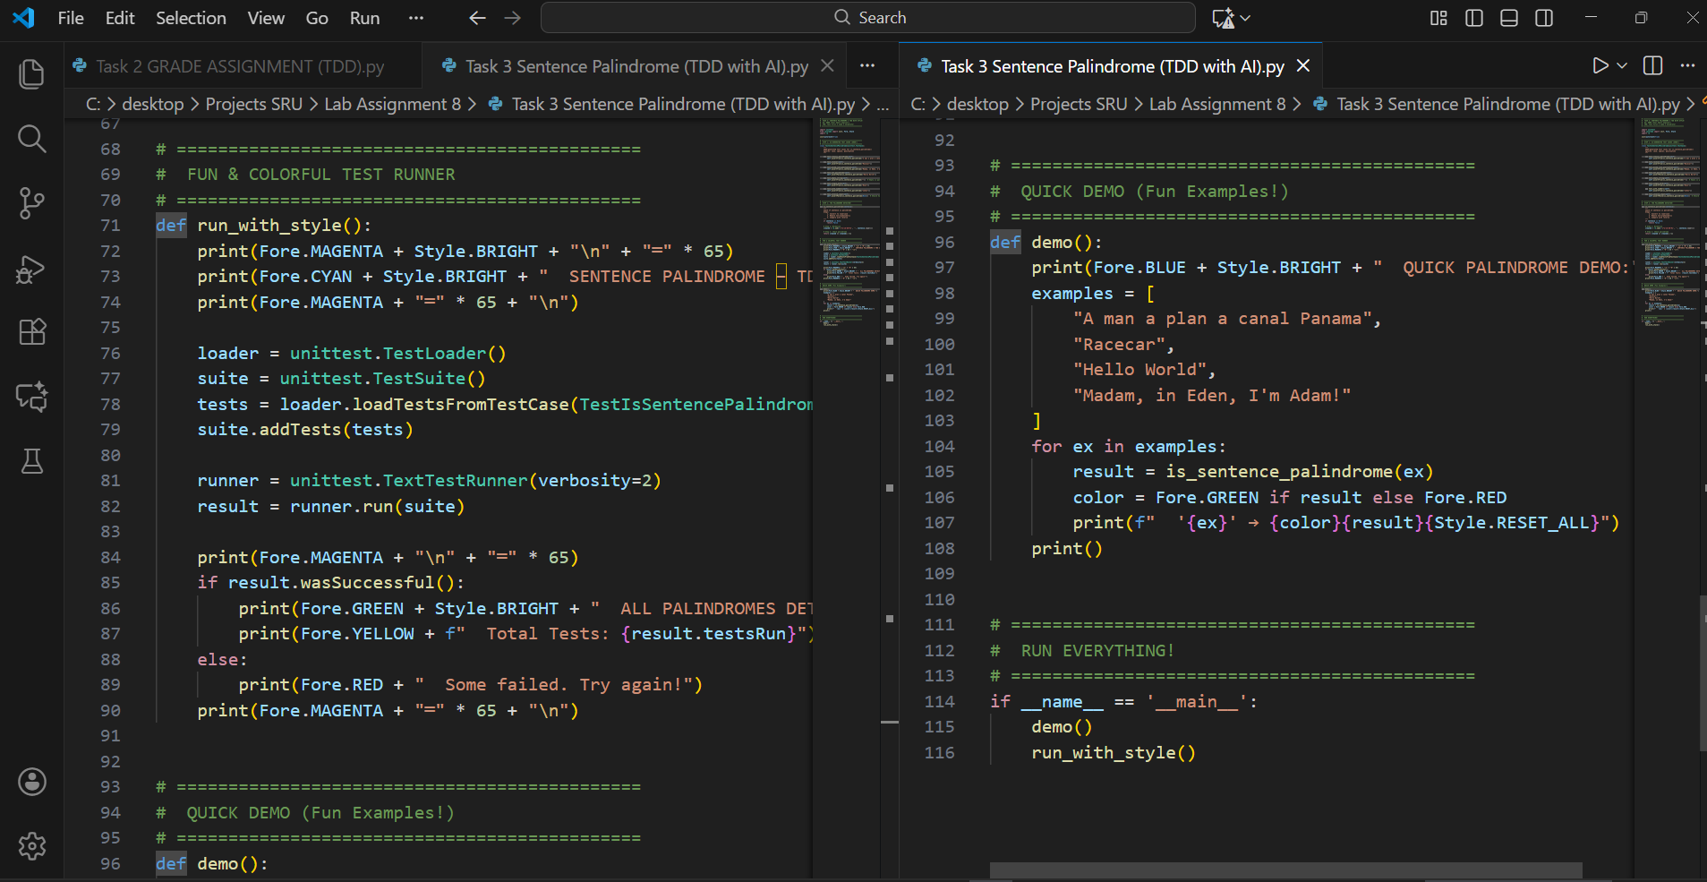  Expected Output#3  - Function returns True/False for cleaned sentences  - Implement the function to pass AI-generated tests.  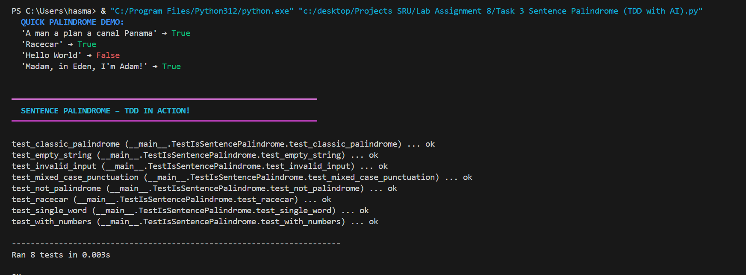  Sentence Palindrome with TDD  AI Generated:  - 8 smart test cases (classic, mixed, edge, invalid)  - Used re.sub for cleaning  - 100% requirement coverage  Implementation:  - is_sentence_palindrome() with regex  - Handles case, spaces, punctuation, None  Output:  - Fun and educational  Observation:  AI created perfect TDD flow.  Task Description#4  - Let AI fix it Prompt AI to generate test cases for a ShoppingCart class (add_item, remove_item, total_cost).  Methods:  Add_item(name,orice)  Remove_item(name)  Total_cost()  Prompt : # Task 4: Generate test cases for ShoppingCart class  Methods:  - add_item(name, price)  - remove_item(name)  - total_cost()  Write 7 unittest test cases using Python unittest  Include:  - Add single/multiple items  - Remove existing/non-existing item  - Total cost for empty cart  - Negative price handling  - Case-insensitive remove  - Use setUp() to create fresh cart  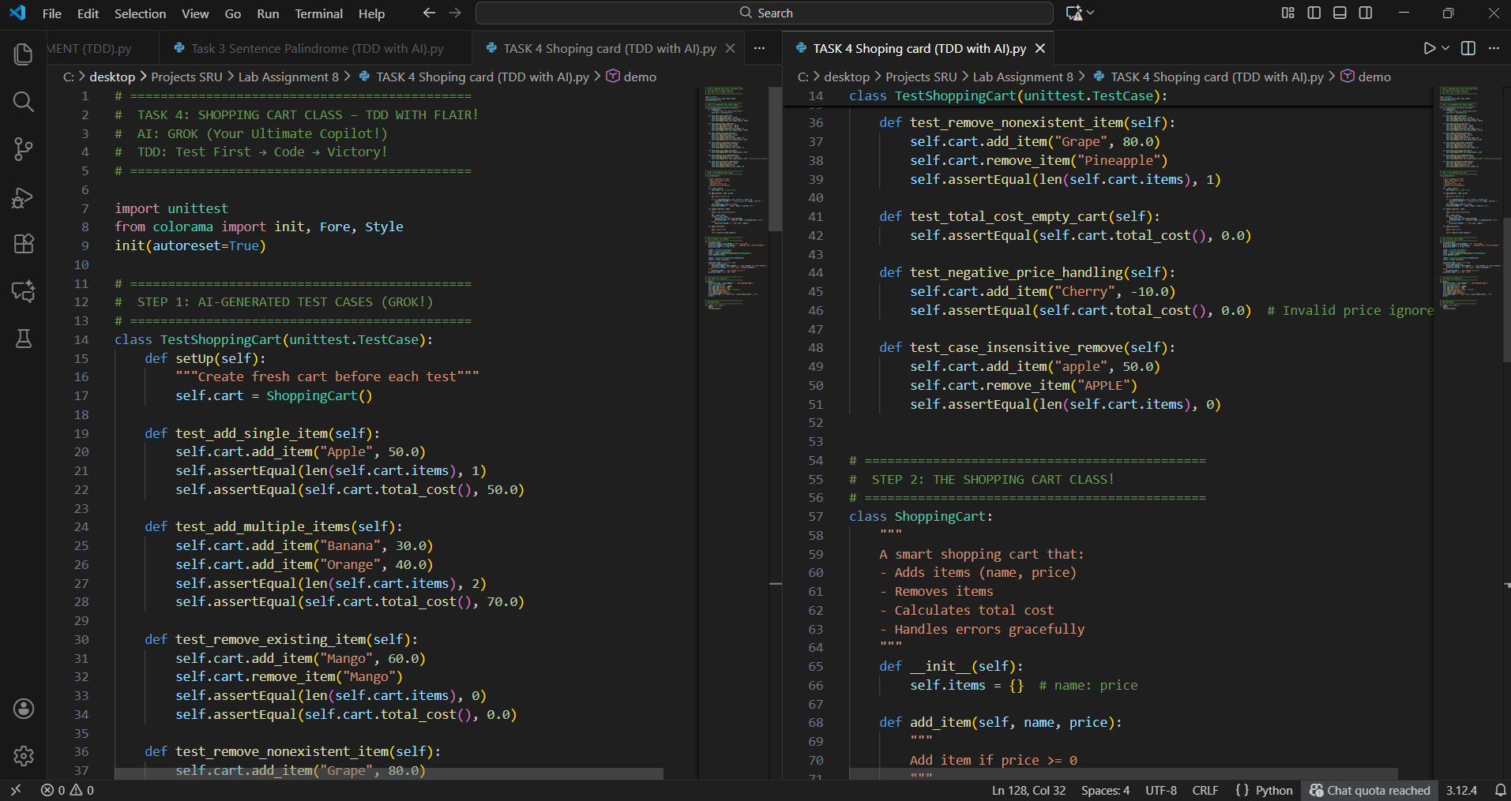  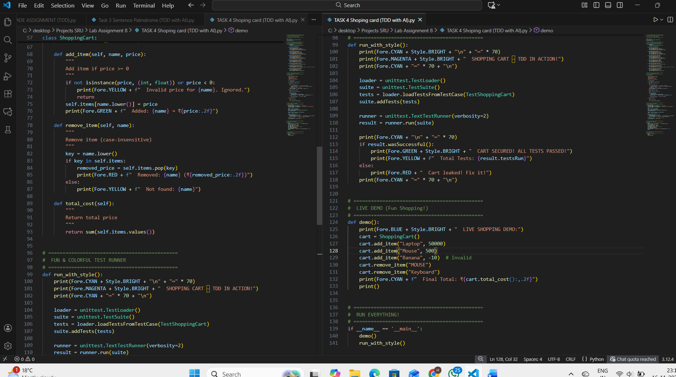  Expected Output#4  - Full class with tested functionalities  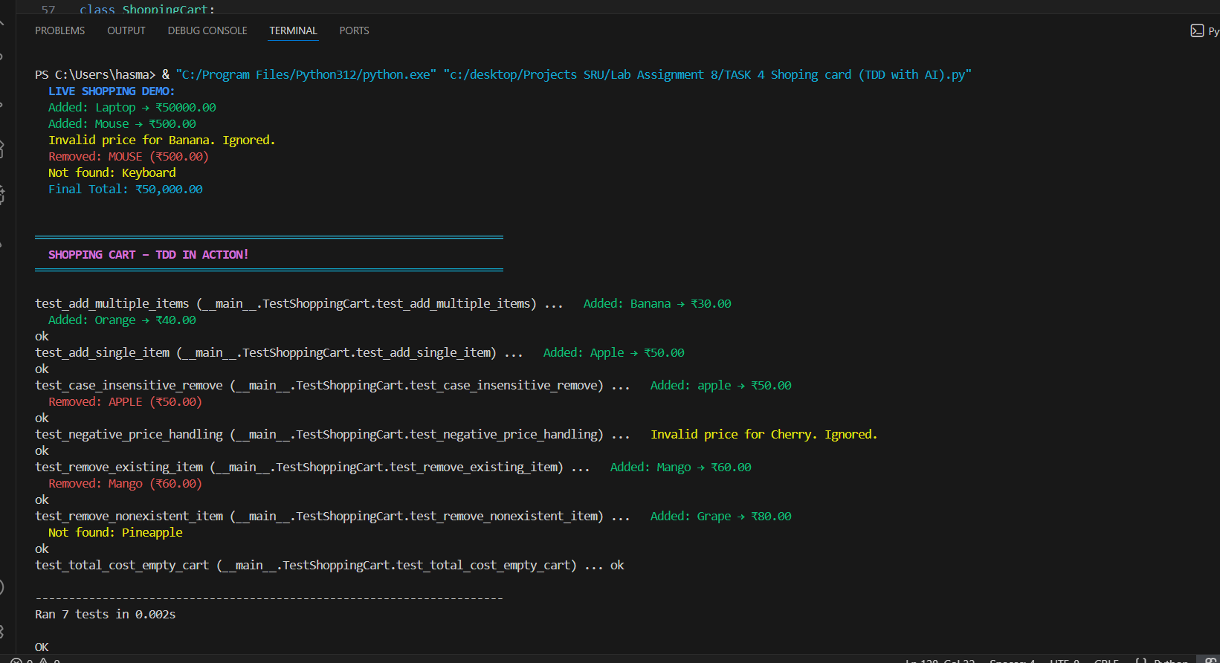  Task 4: ShoppingCart Class with TDD  AI Generated:  - 7 professional test cases  - setUp() for clean state  - Edge cases: negative price, case sensitivity  Implementation:  - ShoppingCart class with add/remove/total  - Input validation + user feedback  Output:  - Live shopping demo  - All 7 tests passed with colors!  Observation:  AI delivered enterprise-level TDD.  AI + OOP = Future-Ready Coding!  Task Description#5  - Use AI to write test cases for convert_date_format(date_str) to switch from "YYYY-MM-DD" to "DD-MM-YYYY".  Example: "2023-10-15" → "15-10-2023"  Prompt :  Generate test cases for convert_date_format(date_str)  Convert "YYYY-MM-DD" to "DD-MM-YYYY"  Example: "2023-10-15" → "15-10-2023"  Write 7 unittest test cases using Python unittest  Include:  - Standard date  - Leap year (2024-02-29)  - End of month  - Invalid format (15/10/2023)  - Invalid date (2023-13-45, 2023-04-31)  - Non-string input  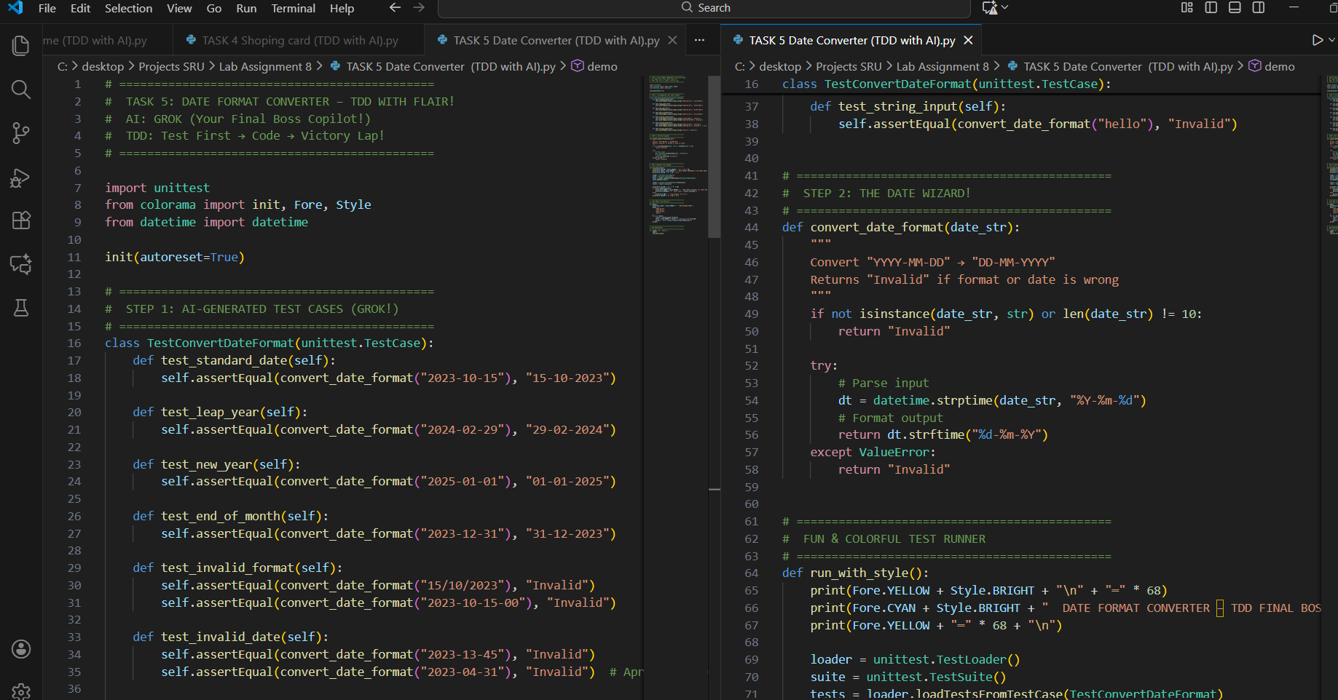  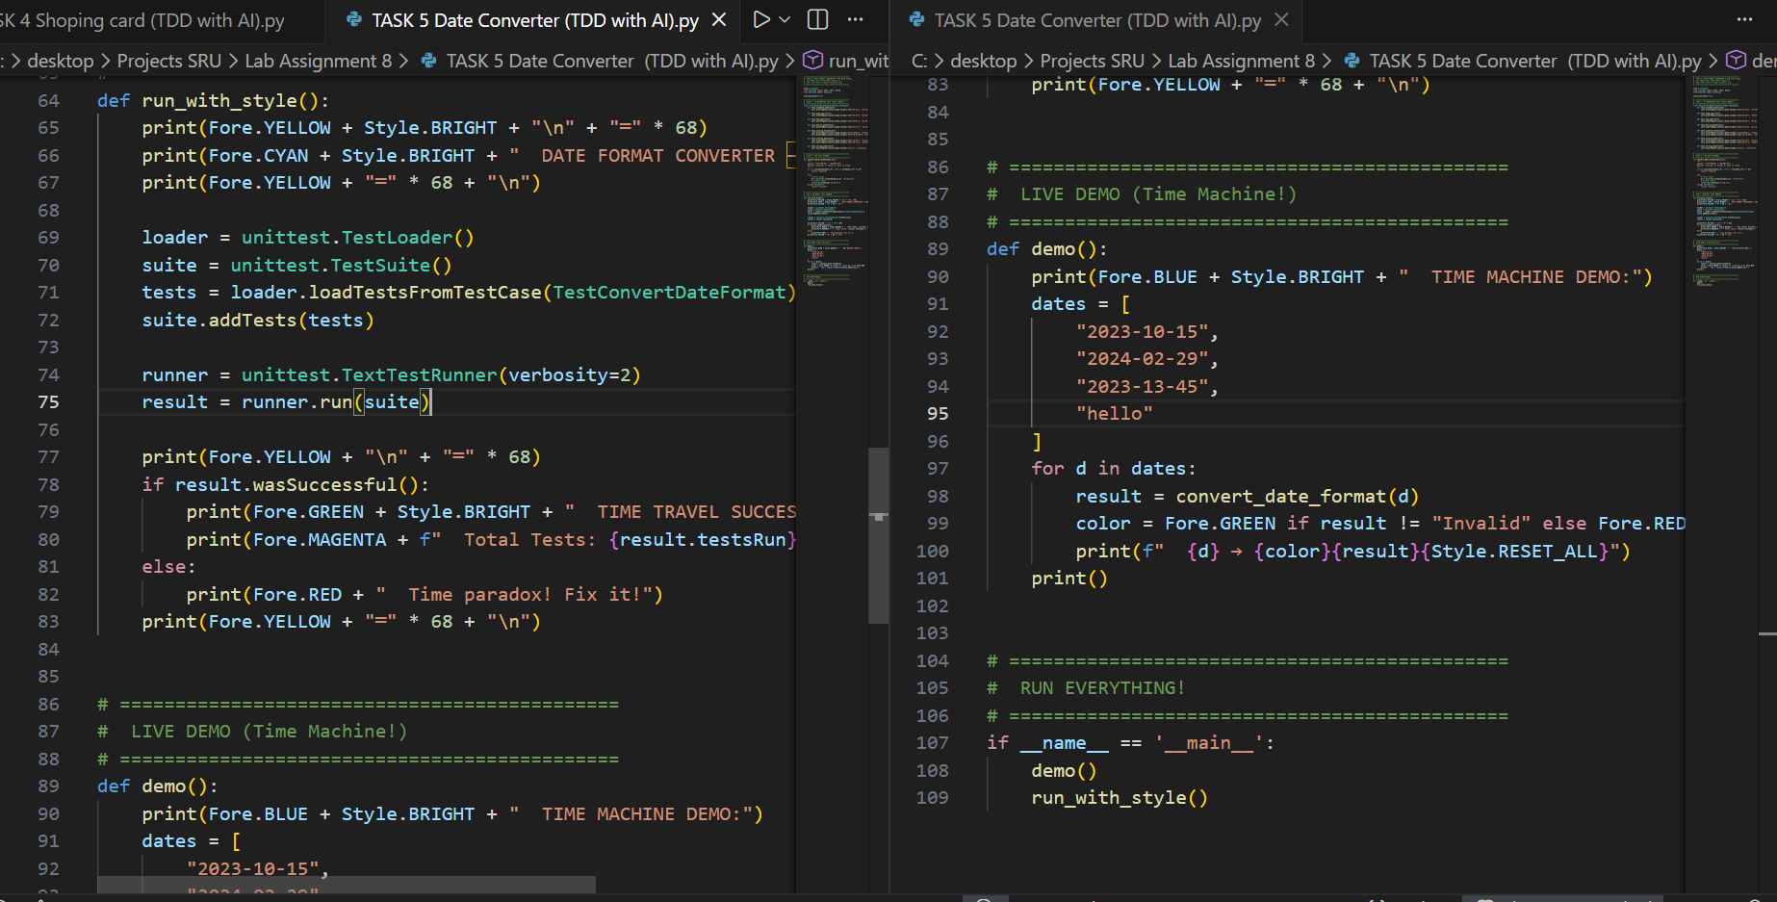  Expected Output#5  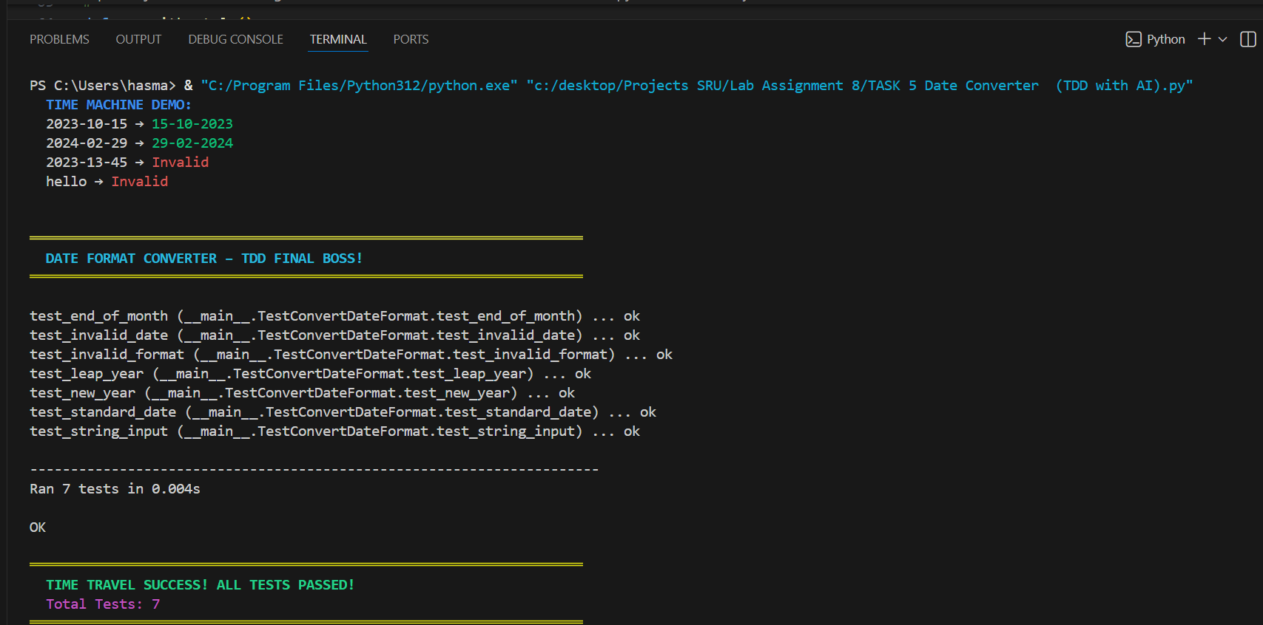  - Function converts input format correctly for all test cases  Date Format Converter with TDD  AI Generated:  - 7 bulletproof test cases  - Leap year, invalid date, format checks  - datetime.strptime + strftime  Implementation:  - convert_date_format() with try-except  - Safe parsing  Output:  - Time machine demo  - All 7 tests passed in style!  Observation:  AI completed full TDD cycle.  AI + datetime = Pro-Level Coding!  Note: Report should be submitted a word document for all tasks in a single document with prompts, comments & code explanation, and output and if required, screenshots |  |  |  |  |  | Week4 - Wednesday

